

WELCOME





##### GLA University Mathura

**Department of CSE (3Year)**



**Introduction**

**Developers / Team Members:**

* **Lokesh yadav (181500351)**
* **Alok kumar Upadhyay ()**
* **Mridul Srivastava (181500395)**
* **Anubhav Tomer()**





##### HEALTH AND FITNESS

**Poject Title**



**Outline**

1. Understanding of the Problem objective &implication.
2. Understanding of the data & building of the model.
3. Evaluation of the model.



**Purpose:**

* **To develop a website where people get the knowledge of health and fitness. In website we give the basic knowledge like Weight Loss, Exercise etc.**



**Application Description:**

* **Health and fitness is a website that provides a basic knowledge of health.**
* **This website also provides how to boost your metabolism in body.**
* **This website will give you the knowledge how to maintain a balance between life and health.**
* **The following presentation provides the deep knowledge of the website.**



**System Requirements:**

1. **Software Requirements.**
2. **Hardware Requirements.**



1. **Software Requirements:**
   * **ANY Operating System (Windows 10 / 8, Linux, Mac)**
   * **HTML**
   * **CSS**
   * **JAVASCRIPT**
   * **MySQL**
   * **PHP**
   * **Github**



1. **Hardware Requirements:**
   * **Minimum Marshmallow version 7.0(for android).**
   * **Hard disk : 250gb or more**
   * **Ram : 4 GB or more**
   * **Processor i3 (7th generation)**

We used the above mentioned hardware tools for increased speed. reduced complexity and for improved productivity.



##### Module Descriptions:

* + **Exercise and Weight Loss**
  + **How Exercise Boosts your Metabolism**
  + **Making time for Fitness**
  + **Your Guide to Getting Started**



# Problem Statement

In today’s generation people are more depend

on the internet to find most of the things peoples

often waste their time in searching healthy tips

so they have to visit a different websites for

Finding proper tips and solutions to accomplish

Their needs.

So we design a website which solve all the

Problems.

**Home page**



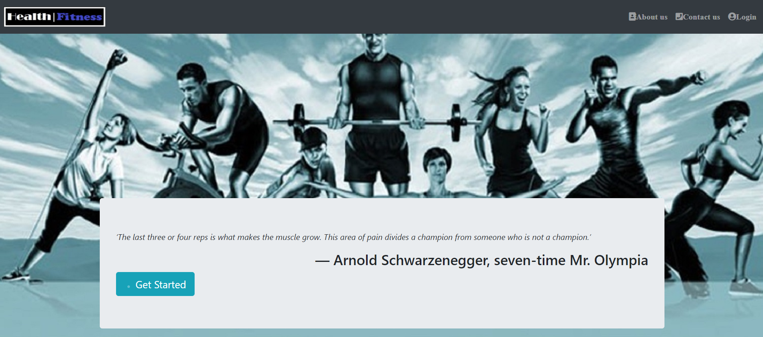

**About section**



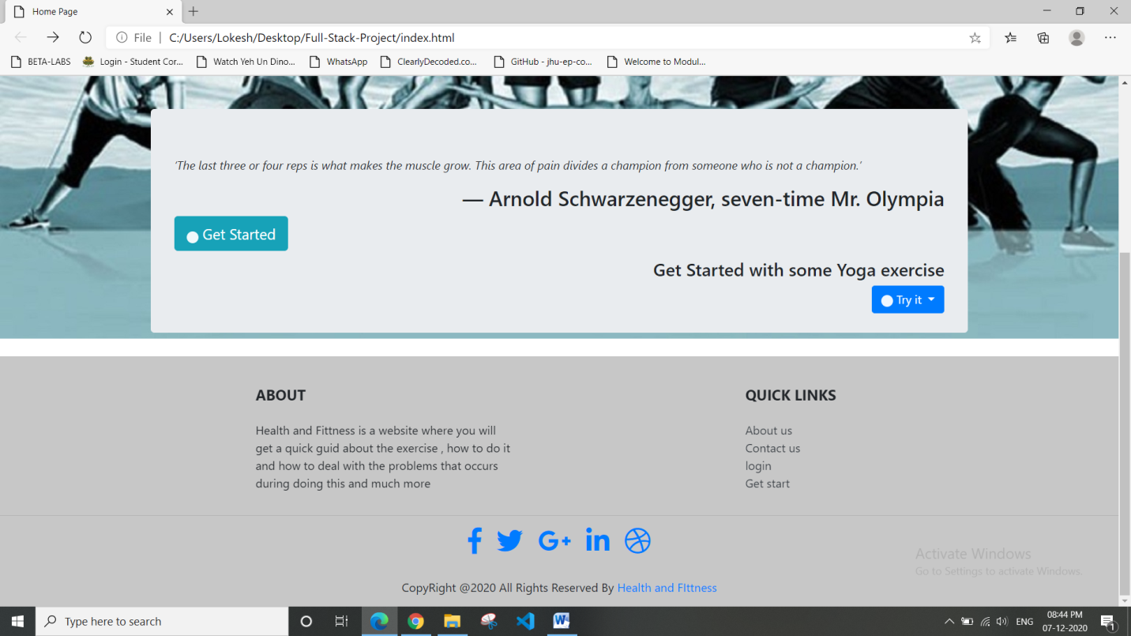



1. Health & Fitness page

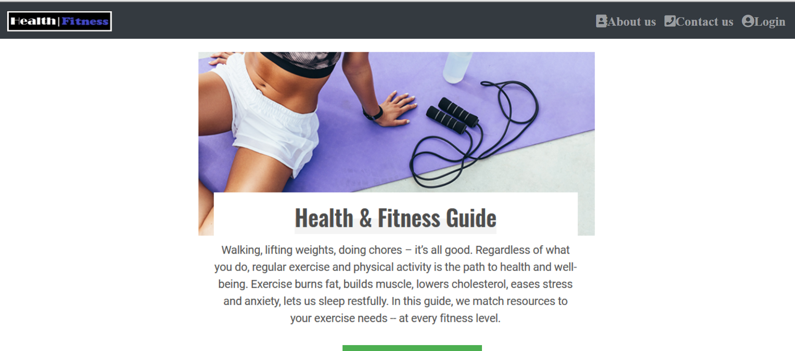

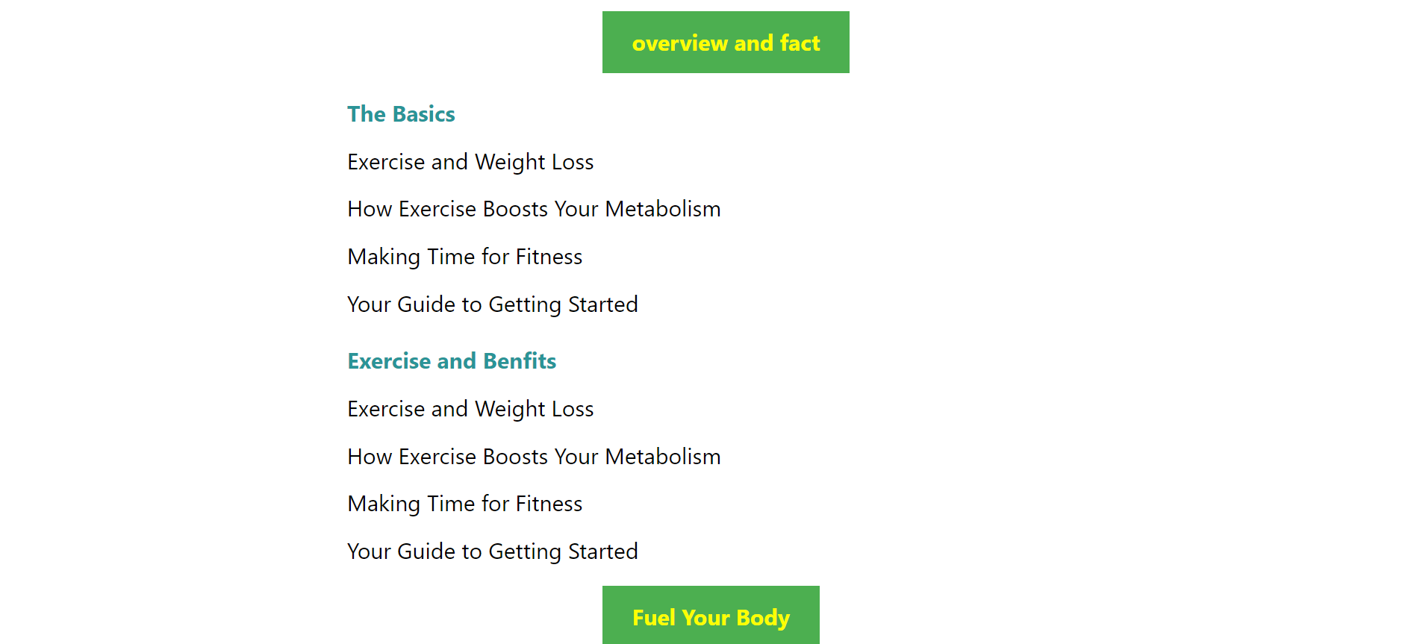



## health4.png





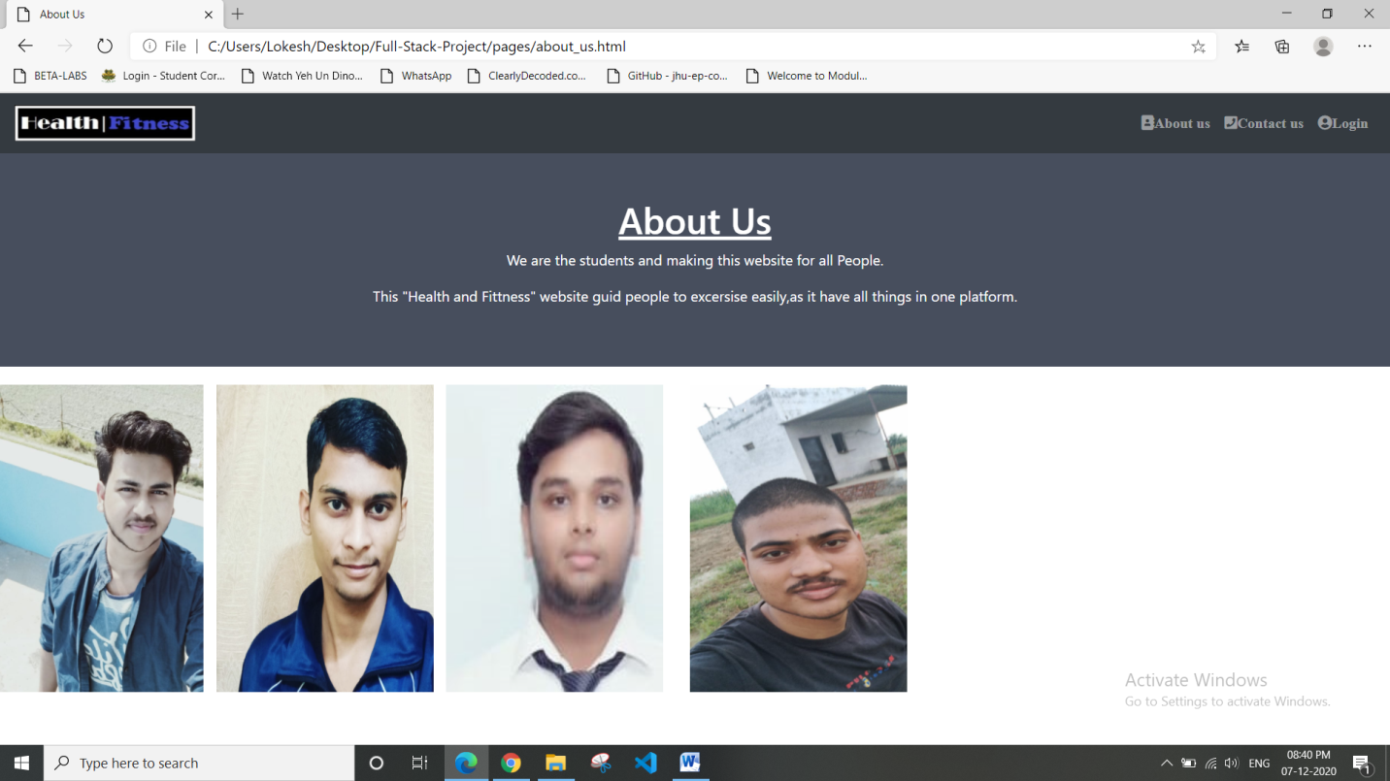



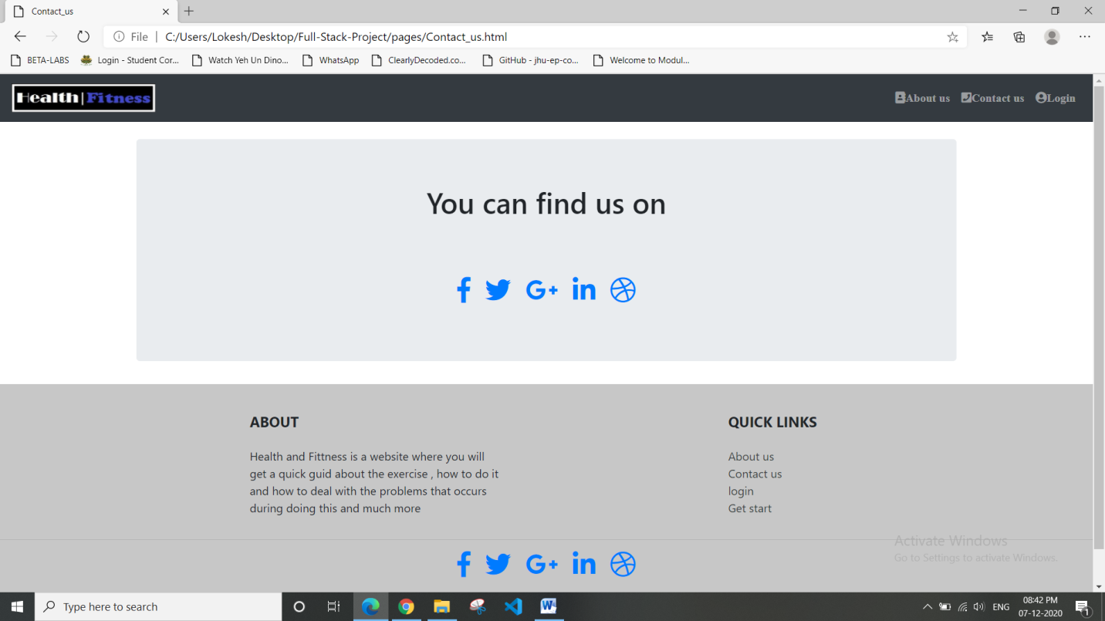



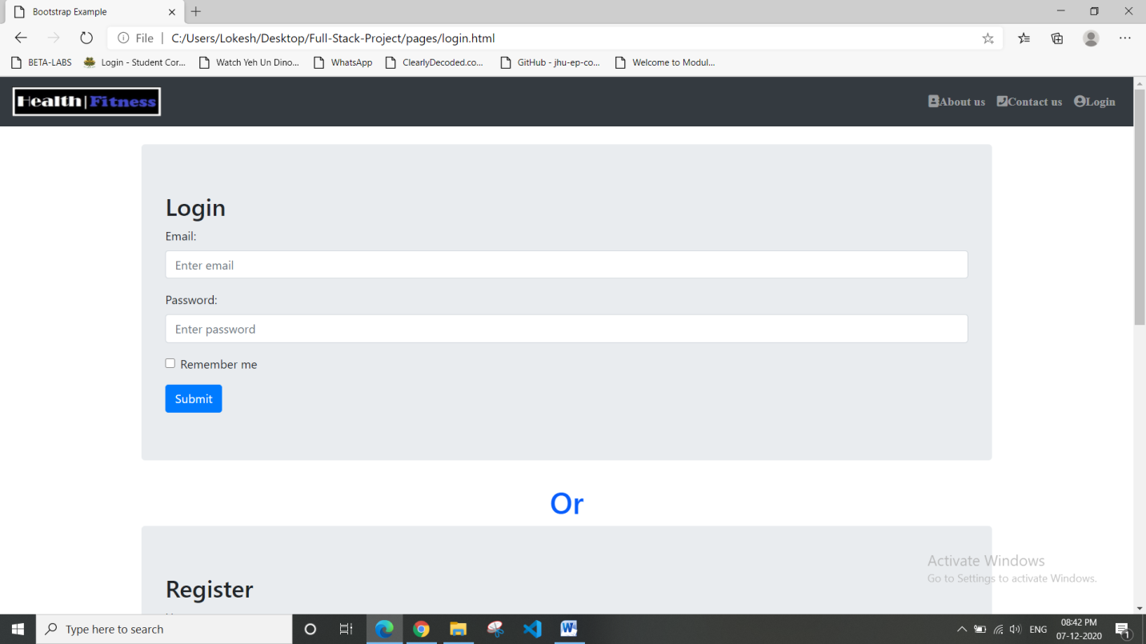



### 



**Thank You**